 4-H Horse Record

The 4-H Horse Record is a summary of your Horse Project for the current 4-H year. Fill out a new record each year. Fill out a separate record for each horse you use as a project animal.

For online record keeping, download and save this Microsoft Word file to your hard drive (FILE/SAVE AS/PermRcd).

Each section of this record contains a table to fill in row by row. You can click your cursor on a gray box, or move from cell to cell across a table row by hitting the TAB key. When the gray field becomes bold, type your entry (type as many lines as you want). To add more rows to a table, highlight the last row, then go to TABLE on the menu bar, click INSERT ROWS BELOW, and release.

We included a page break between the different tables of the record sheet. You may insert additional page breaks between pages and/or parts of the record: go to the menu bar, click INSERT, and choose BREAK… When you release BREAK, then [click the button by PAGE BREAK and click OK —(PC)] or [click PAGE BREAK—(Mac)].

We encourage you to save the document frequently (either FILE/SAVE or press CTRL & S). We also recommend you make a BACKUP copy of the document somewhere else than on your hard drive. Do not include this page for record review or judging.

4-H Jackson County Horse Record, Revised 1/07
© 2004 Oregon State University. This publication may be photocopied or reprinted in its entirety for noncommercial purposes. Produced and distributed in furtherance of the Acts of Congress of May 8 and June 30, 1914. Extension work is a cooperative program of Oregon State University, the U.S. Department of Agriculture, and Oregon counties. Oregon State University Extension Service offers educational programs, activities, and materials without discrimination based on age, color, disability, gender identity or expression, marital status, national origin, race, religion, sex, sexual orientation, or veteran’s status. Oregon State University Extension Service is an Equal Opportunity Employer.
Date record started Closed
4-H Horse Record (one record per horse)
Name Grade Phone
Name of Horse Registration #
Horse Date of Birth Date Obtained Owned Leased
If sold or deceased, list date
Fill out the following information as if you were trying to identify your horse to someone who is not familiar with it.
Sex Breed Color Height Weight
Draw markings, brands, or significant scars on each side and face. Do not color. You may use photos of front and sides as an alternative.
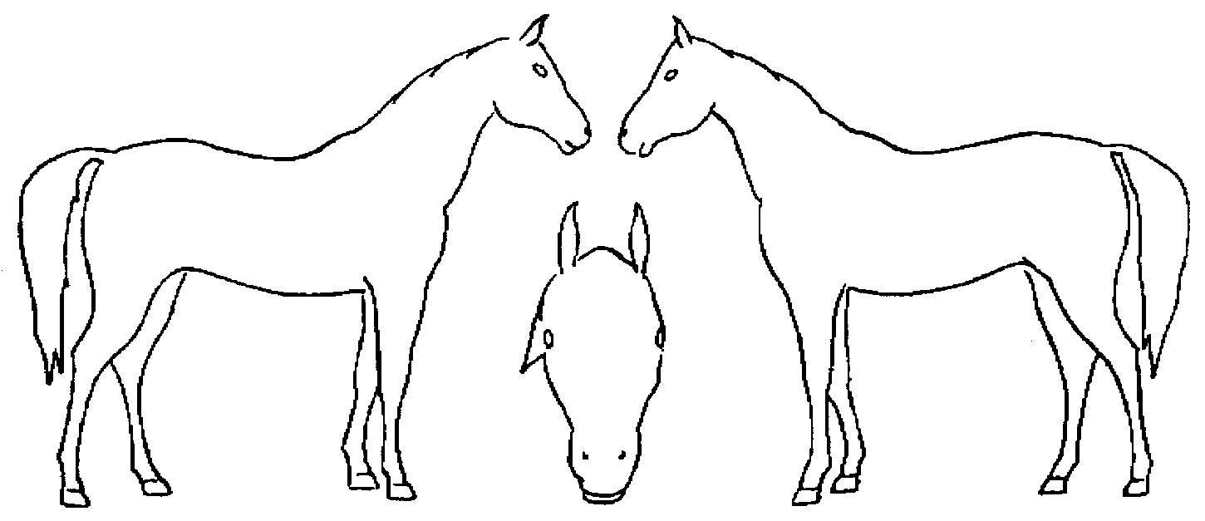

Give a written description of your horse
(Include brands, tattoos, their locations, any special identifying marks, color, etc.)

Project Record Review
________________________________________________
When your project record is completed, print it out and have your 4-H leader (or parent) sign here, and comment below:

Leader’s comments:

Project Statements

Things I Hope to Do and Learn This Year

Things I Did with My 4-H Club This Year
(Tell about your participation in club activities.)

Training/Project Hours
Record the hours you rode the horse listed on this record, and the non-riding project hours, plus a brief description of the type of riding, training, or other hours spent with your project.

 | Project Hours,  Riding | Project Hours, Non-riding | Remarks
Oct
Nov
Dec
Jan
Feb
Mar
Apr
May
Jun
Jul
Aug
Sep
Total
Expenses
Directions: Use round figures (no cents) for all costs and amounts.

Health Care & Maintenance (Health Care includes all veterinary, insurance fees, maintenance, farrier, de-wormer, vaccinations, hoof care, illness, or injury)

Date | Drug, Injury description, Method of de-wormer, etc. | Results | Cost
Total Health Care Expenses (Item #1) $

Feeding & Boarding Expenses

This is the Feeding &Boarding record for the horse listed on this record. Use a separate column for each kind of feed you give your horse—grain, (list kind), alfalfa, grass hay, etc. Include all feed, supplements, grain, etc.

 | Boarding  Costs | Amt  or lbs | Cost | Amt  or lbs | Cost | Amt  or lbs | Cost | Amt  or lbs | Cost |  | Cost per  Month
Oct
Nov
Dec
Jan
Feb
Mar
Apr
May
Jun
Jul
Aug
Sep
Totals
Total Feeding Expenses (Item #2)

4-H Jackson County Horse Record, Revised 1/07
© 2004 Oregon State University. This publication may be photocopied or reprinted in its entirety for noncommercial purposes. Produced and distributed in furtherance of the Acts of Congress of May 8 and June 30, 1914. Extension work is a cooperative program of Oregon State University, the U.S. Department of Agriculture, and Oregon counties. Oregon State University Extension Service offers educational programs, activities, and materials without discrimination based on age, color, disability, gender identity or expression, marital status, national origin, race, religion, sex, sexual orientation, or veteran’s status. Oregon State University Extension Service is an Equal Opportunity Employer.
Supplies

(These are items that will be used up, like vet wrap, showsheen, shampoo, absorbine, etc. Items purchased near the end of the year will not have a value change or depreciation.)

Date  Purchased | Description | Beginning Value | Ending  Value
Totals
To calculate depreciation expense, subtract ending value from beginning value.
Copy result to Financial Summary on last page (Item #3)

Other expenses

(Other includes transportation costs, entry fees, show fees, event fees, fees for lessons, or anything that may not fit in another place.)

Date | Description | Cost
Total Other Expenses (Item #4) $

Inventory
List the value of all hay, grain, tack and supplies you own at the beginning of the year (Oct. 1, or when you join for the first time). Add items as you purchase them with beginning value, however items purchased near the end of the year will not have a value change or depreciation. Inventory includes all tack and equipment; it is okay to “lump” small items such as grooming supplies. Try to include serial numbers or distinguishing marks for large items. In case of theft, this will make recovery possible.

Item | Beginning  Value | Ending  Value
Totals
To calculate depreciation expense, subtract ending value from beginning value.
Copy result to Financial Summary on last page (Item #5)

Income

Income includes premium monies, sale of a horse or foal.

Date | Description | Amount
Total Income (Item #6) $

Financial Summary

Total Expenses
Health Care Item #1
Feeding & Boarding Item #2
Supply depreciation expense Item #3
Other Item #4
Inventory depreciation expense Item #5
Total Expenses | $
Income Item #6
Total Expenses, less income | $

Notes (or Member’s personal Review of Project):

